Lab: <https://killercoda.com/>

You can authenticate yourself with below methods, but we suggest you to go with google authentication.

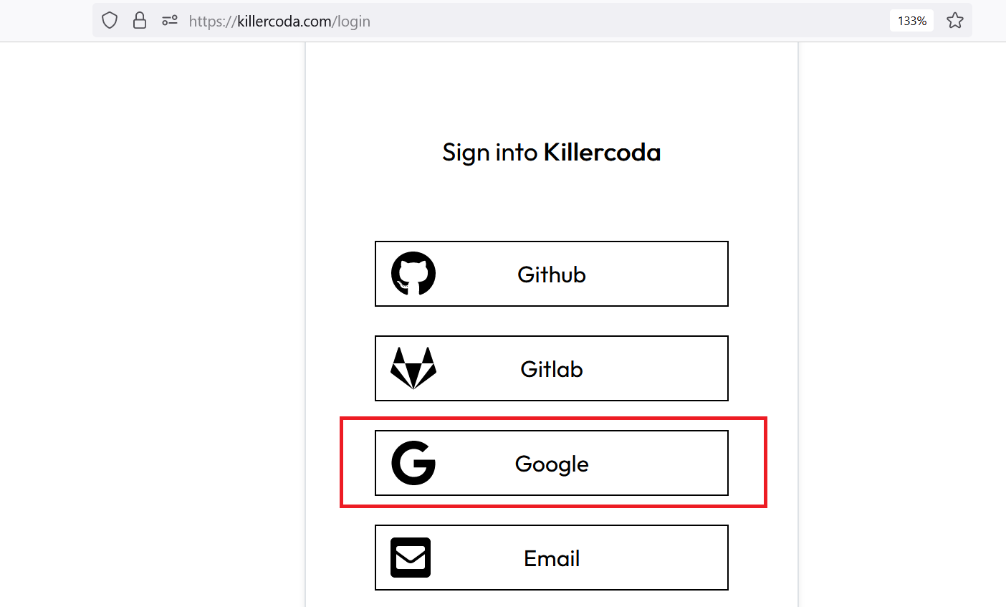

Now, you have all listed lab for DevOps-

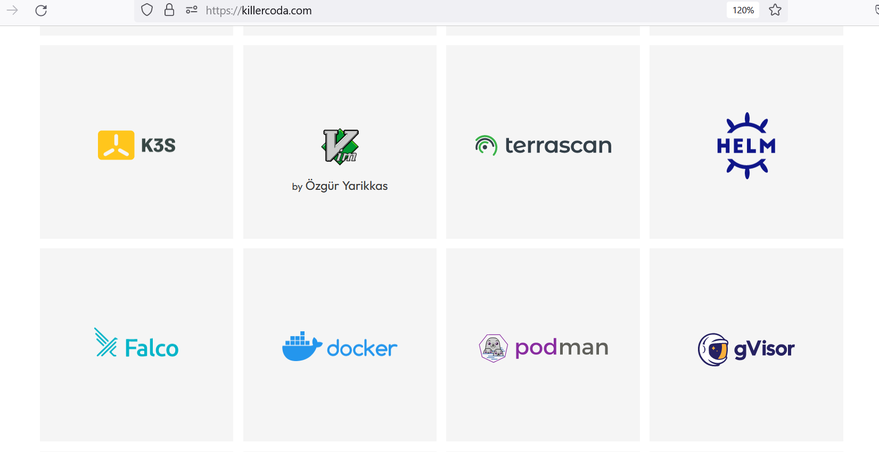

Even you have empty Linux box:

<https://killercoda.com/playgrounds>

Introduction:

When we are thinking for certification then couple of vendors come into picture like-

* AWS: For cloud related certificate
* CISCO
* Redhat

These vendor charge Money and provide stamping to your skill.

On other hand IBM come up with idea that “Education is right for everyone, and they provide 1000+ free certificate to all the people who do that, and validate them as well.

Note: All of these certificates are free, you are not supposed to pay anything.

What learning portal we would be using during certification?

There are two portals-

1. Credly > <https://info.credly.com/>

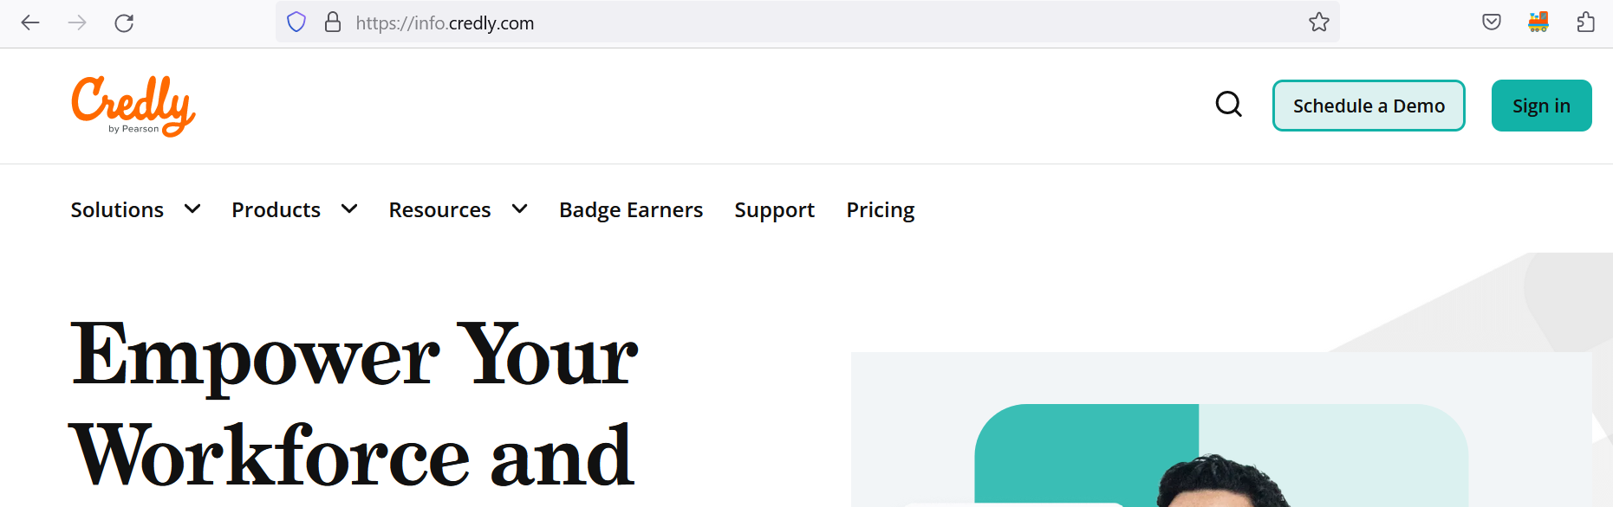

1. Cognitive ai > <https://cognitiveclass.ai/>

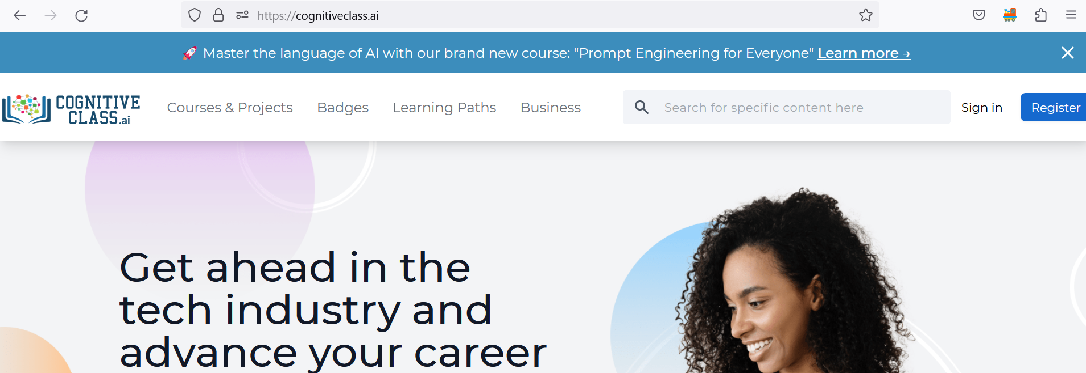

When you are creating account in above URL, kindly use Google to validate, it verifies your account very fast else you need to wait for 24 hrs to get your account setup.

As a first step we need to create account in these portals.

Now, let me talk more about these portals:

Credly: Credlyplatform hosts the largest and most-connected digital credential network. Reward your learners & transform skills into verified, shareable digital credentials. It manages your certification dashboard.

Cognitive ai: it’s learning portal which provides 1000+ free course.

How to get certificate?

Step1: Go to search icon and select the course of your interest.



Step2: Once you select the course you need to enrol and start that course.

Step3: During the course you would be getting module wise, and final time bounded quiz. You need to give answers to them. And based on your answers and certificate criteria you would be getting certificate/badge awarded.

What certificate recommended for Devops Engineer?

* Docker Essentials: A Developer Introduction
* Containers & Kubernetes Essentials
* Beyond the Basics: Istio and IBM Cloud Kubernetes Service
* Building Cloud-Native and Multicloud Applications
* Data Science for Business - Level 1
* Cloud Native Security Conference - App Security
* Cloud Native Security Conference - Data Security
* Cloud Native Security Conference - DevSecOps
* Introduction to cloud
* Core Cloud
* Data Science Methodologies
* Data Visualization Using Python
* DataOps Methodology
* IBM Cloud Essentials

How to see which certificate I completed?

Once you done with timed exam, you need to click on certificate and badge, and accept bedge

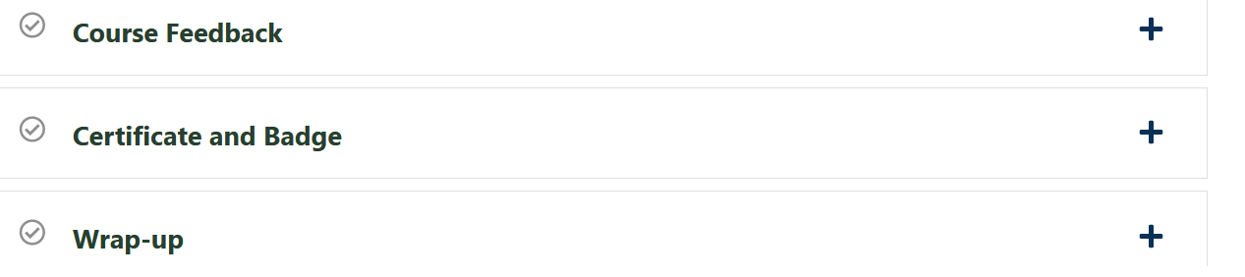

How to see certificate and Credly dashboard?

Click on share tab

